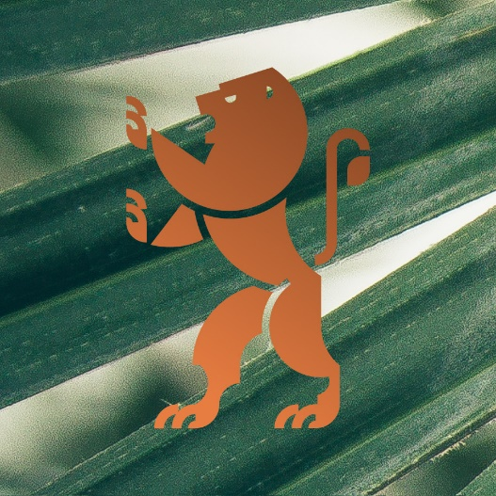
Together we share the Earth, this land, this soil regardless of the faith (or lack of faith) that divides us.

Earth is one of the four basic elements of the world, which when treated humanely (with love), repays with fruit but when treated "humanly" it opens up and devours us.

Judaism teaches us show to respect and look after this natural heritage, our Earth. This is what Rabbi Moses Isserles Remuh and Maimonides teach us, but firstly, this is what the Torah teaches us.

Judaism teaches us how to make the earth obey us, how to wisely use its water resources, how to keep the air clean. It also teaches us meekness towards fire which will always be stronger than the human being.

The Earth, this land, this soil which we come from and to which we will return is given to us for a short moment, but in our greedy stupidity we destroy it for ever instead of wisely making it obey us.

This year, we are putting up our tent on the land of Kazimierz where the Ashkenazi civilization flourished for ages. Krakow remained the focal point of Jewish life in the Diaspora for centuries. Its grandeur and greatness served the glory of the People of Israel, so it was called:

Ir Va-Em Be-Yisrael, City and Mother in Israel (2 Samuel 20:19)

To express their longing for Yerushalaim, the Jews used to call their cities Little Jerusalem. Krakow was Little Jerusalem for ages and the civilization which the Jews created brought together the land of Krakow and the land of Israel.

The Land of Krakow and Kazimierz. Eretz Yisrael, The Land of Israel. Polin/Israel – the promised land, land which was taken away, land of milk and honey, land of blood and ashes, blessed land, damned land, God's land, Satan's land, human land, inhuman land, fertile land, barren land, land of mercy, land of hatred, land filled with fruit, land of stones and bones, hospitable land and lost land. Graveyard land. Recovered Land. Mother Earth.

The history of the earth and its heritage teach us and force us to live responsibly. Fully aware of this responsibility we will try to learn what we can do to protect our identity that is inseparably connected with this Earth, this land, this soil in our lectures, workshops, meetings and concerts.

Over the next seven and seventy-seven years we will discover the beauty of the four elements of the world enriched with Jewish culture. We have chosen to start off with the land, the soil where thousands of years ago Jewish civilization sowed its eternal seed.

Janusz Makuch
founder and director
Jewish Culture Festival in Krakow

Translation: Klara Laudańska

